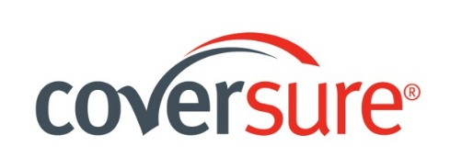
CLEANING CONTRACTORS – ADDITIONAL QUESTIONNAIRE

- Please provide a full split of turnover derived from the following categories:

Category | Split (%) for Recent 12 months | Split (%) for Next 12 months
Office and Industrial Cleaning Outside of Business Hours
Office and Industrial Cleaning During Business Hours
*Retail Shop Outside Business Hours
Retail Shop During Business Hours
Shopping Centre Outside Business Hours
Shopping Centre During Business Hours
Aged Care / Child Care Outside Business Hours
Aged Care / Child Care During Business Hours
Schools Outside Business Hours
Schools During Business Hours
Other - Please specify :

Total | 100% | 100%
*Retail includes Shops, Arcades and Shopping Strips, whether stand-alone or part of a commercial building.

- Does any of the above include the Department store ?

Yes ☐ , please provide example _____________________________
No ☐

- Do they do trolley collection ?

Yes ☐
No ☐

- Do they clean food courts for shopping malls ? If yes, Please indicate whether it is performed during business hours or outside business hours.

Yes ☐ : During hours ☐ Outside Hours ☐
No ☐

- Do they hire independent (third party) risk managers or OH&S managers?

Yes ☐
No ☐

- Please provide what risk management systems have been implemented to control any hazards ?

Please attach copy if available (eg. OH&S manuals, Quality manual, Hazard assessment form, duty statement and employees duty checklist etc.)

- Is CCTV footage available of all work areas?

Yes ☐
No ☐

- Are you involved in any of the following ?

- Window Cleaning Yes ☐ No ☐ - If Yes, maximum heights : _____m
- Exterior Wash Down Yes ☐ No ☐ - If Yes, maximum heights : _____m
- High Rise Window Cleaning Yes ☐ No ☐ - If Yes, maximum heights : _____m
- Abseiling Building Maintenance Yes ☐ No ☐ - If Yes, maximum heights : _____m
- Ceiling Cleaning Yes ☐ No ☐ - If Yes, maximum heights : _____m
- Water Blasting Yes ☐ No ☐ - If Yes, maximum heights : _____m
- Abseiling Cleaning Yes ☐ No ☐ - If Yes, maximum heights : _____m
- High Dust Cleaning Yes ☐ No ☐ - If Yes, maximum heights : _____m

- Other supplementary information you would like to disclose ?

